Hello Parents,
We hope that you and your family are safe and doing well.
We are delighted to inform you that many of the UCMAS Centres across Canada & USA are gradually re-opening with limited number of students per class. We are strictly adhering to all the official guidelines, social distancing norms & sanitization procedures at our UCMAS Centres.
We have mentioned below some of the health & safety guidelines and measures for our centre, that need to be followed under every circumstance.

HEALTH & HYGIENE MEASURES
TAKEN AT THE UCMAS CENTRE:

- Strict health and hygiene measures have been put in place to maintain a healthy environment all the time.
- Each student desk is set up with the physical distance policy.
- Alcohol-based cleaning solutions are used to sanitize each desk and any shared materials by students to maintain the cleanest and bacteria-free environment at all times.
- Tables and chairs will be sanitized with disinfectant wipes after each class.
- Tissues are provided for students and staff to comply with cough and sneeze etiquette.

ATTENDING REGULAR CLASSES AT THE CENTRE
- Please do not encourage your child to attend the UCMAS class if they feel sick at all. We will provide a makeup class once your child feels better and overcomes the illness.
INSIDE THE CENTRE:
- Physical distance of 2-meter needs to be maintained by students at all times in the UCMAS Centre.
- kindly note that parents are not allowed to enter the centre during the ongoing class.
- Parents and students are strongly recommended to avoid greetings that involve physical contact, such as shaking hands. Use alternative ways to greet people.
- Staggered schedule for the drop-off and pick up in between classes by 15-20 minutes
- Designated pick up and drop off areas marked outside
- One-on-one parent feedback by phone after the class, if required
- Guidelines displayed on TV screens and posters at the Centre.
- Maximum 4 to 5 students in a classroom size of 150 Square feet classroom.
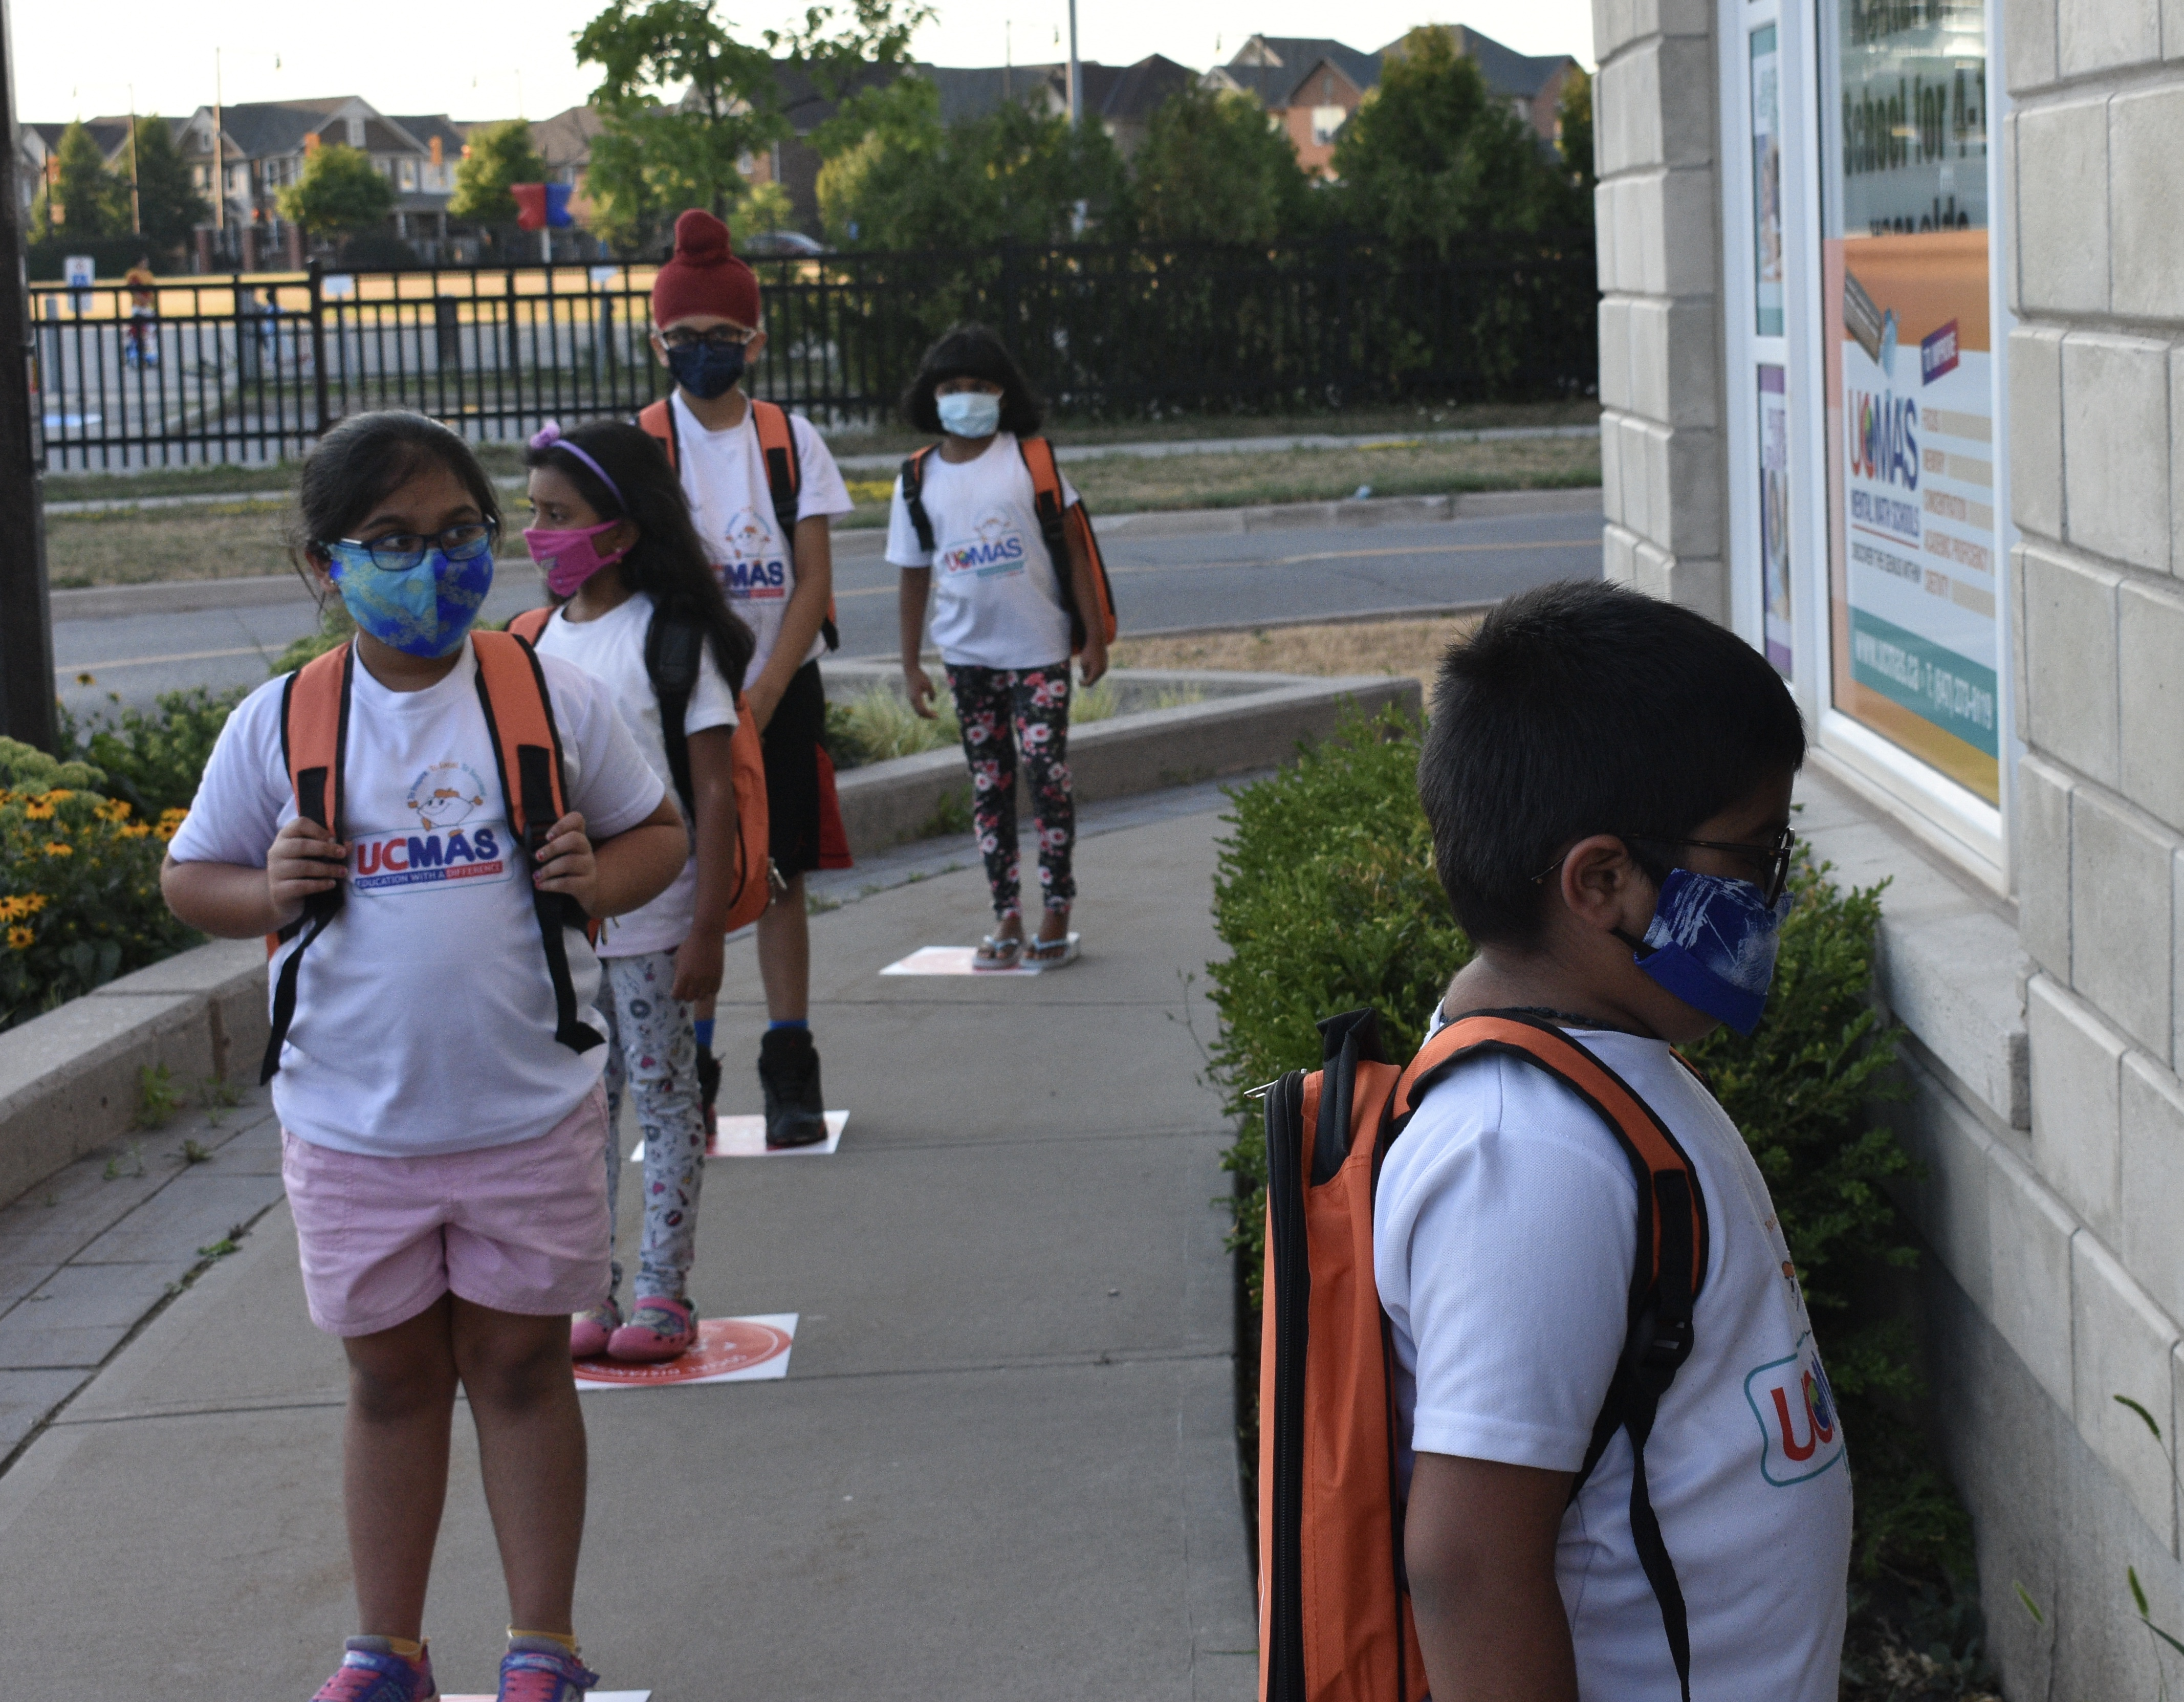

INSIDE THE CLASSROOM:
- Every student is required to bring their own water bottle to avoid any contamination.
- Studnets will be asked to avoid bringing snacks to the center to maintain more hygenic measures. 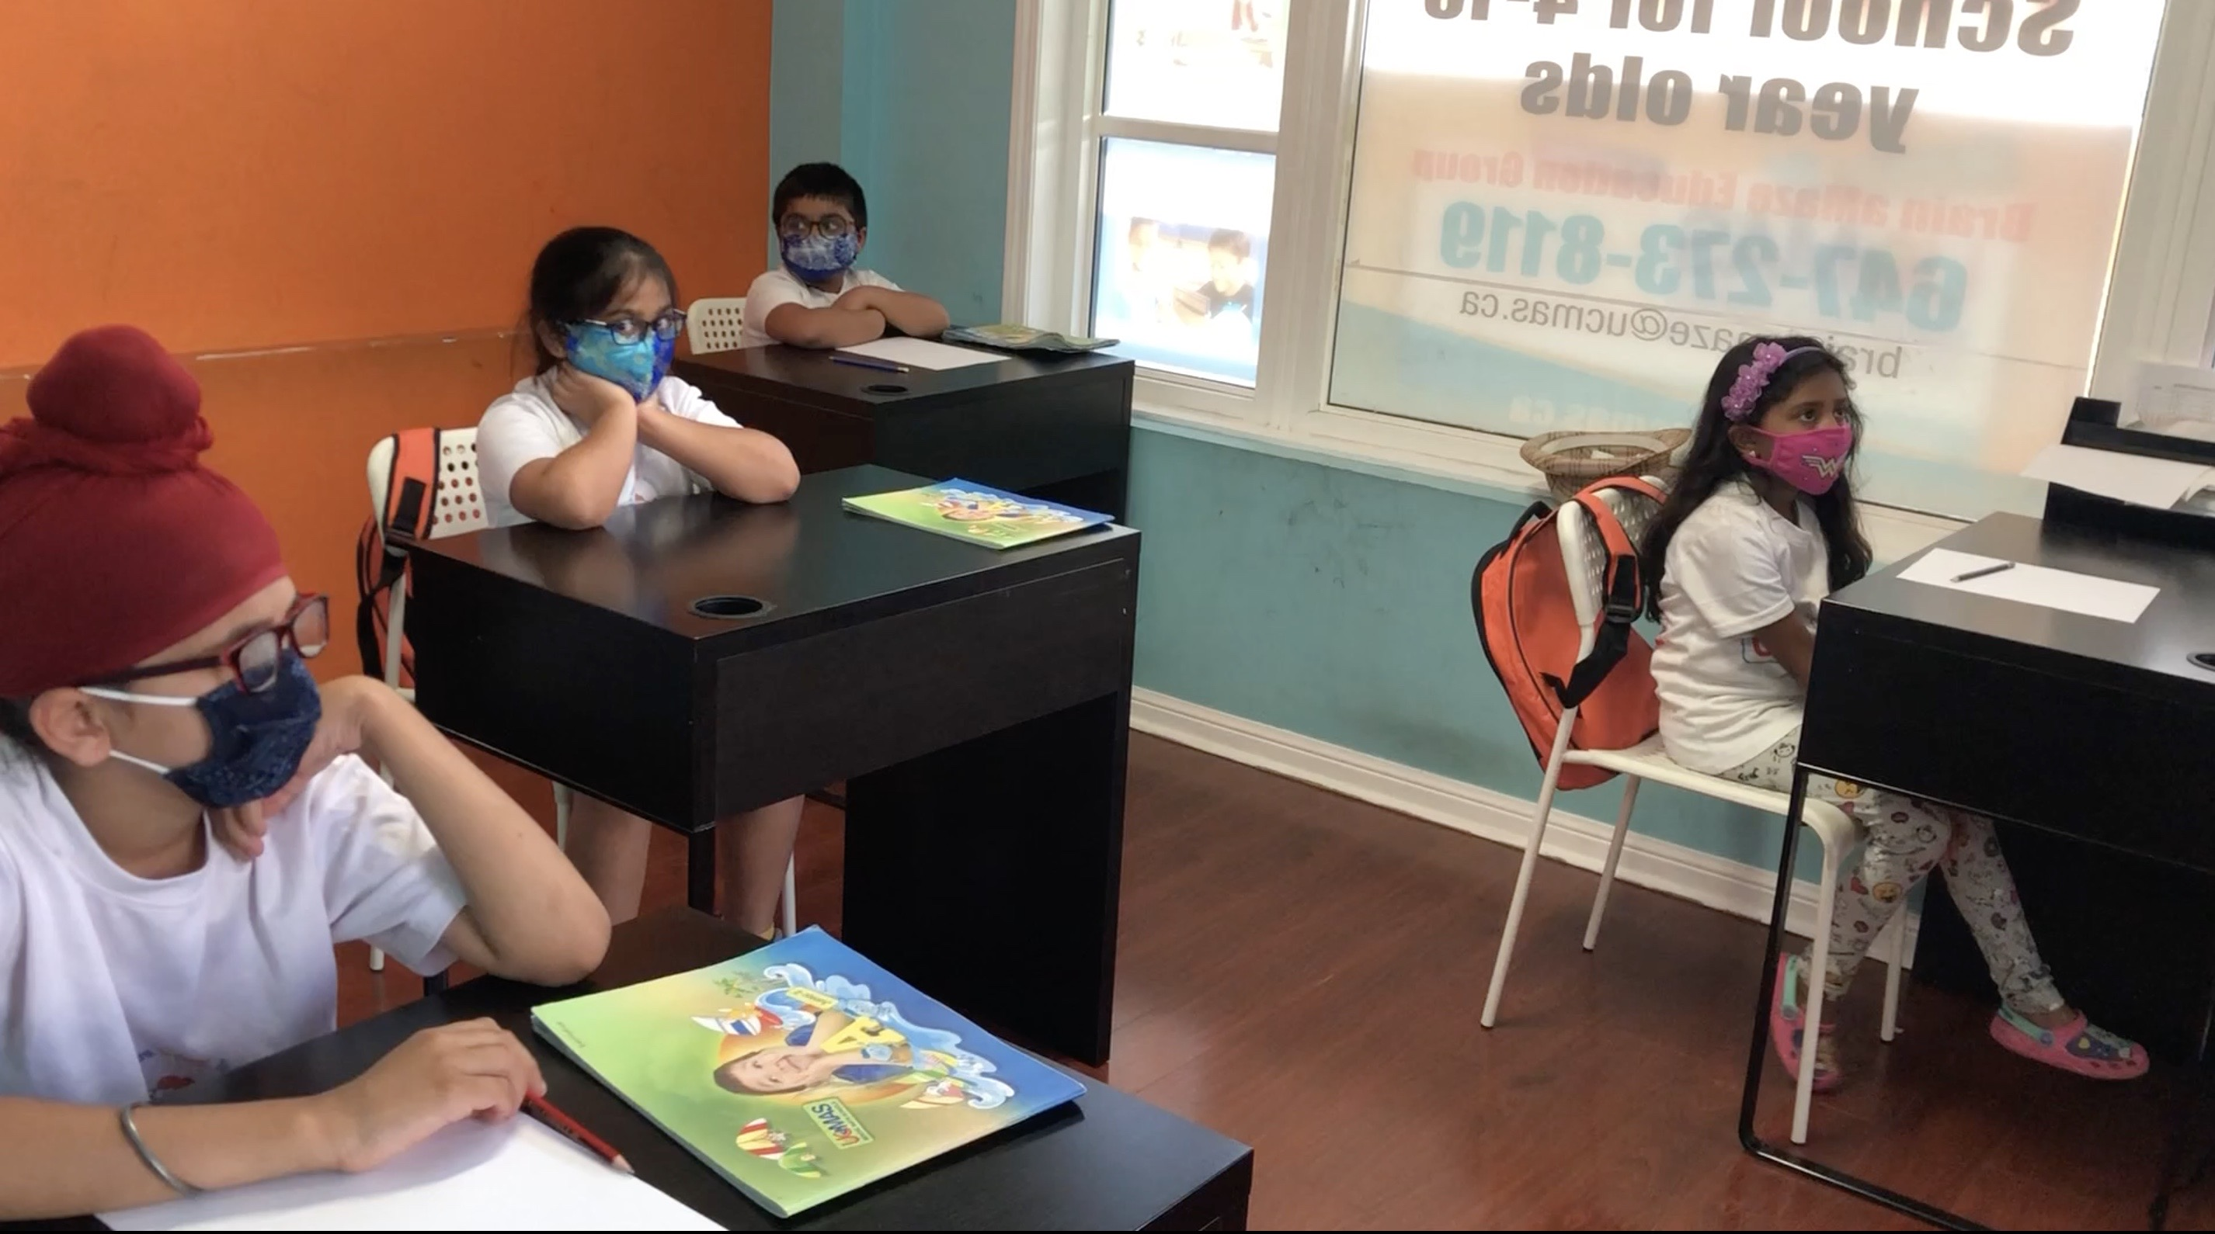
- During the break time, only two students will be allowed to use the washroom at the same time.
- Masks will be mandatory for each child while in-doors
- As much as possible, students must avoid sharing items (pencils, sharpener, toys, copybooks, dishes, utensils, etc.).
- Students are not encouraged to leave their designated desk during the class or touch other student’s desks under any situation.
- Reduced number of desks and chairs in each room
- Floor markings to maintain appropriate distance
- Clear plastic sneeze for Course Instructors
- Staggered schedule for the drop-off and pick up in between classes by 15-20 minutes
- Designated pick up and drop off areas marked outside
- One-on-one parent feedback by phone after the class, if required
- Guidelines displayed on TV screens and posters at the Centre.

“It is mandatory for every student to follow these health recommendations during this pandemic at the UCMAS Centre to ensure safe & healthy environment.”
It is advised that parents make students understand these guidelines, so that they are aware of the expectations. If students fail to obey these safety guidelines or unable to cooperate with the staff then they will be asked to discontinue until the situation gets normal.

We are excited to see students at the UCMAS centre.
I wish everyone great health and enjoy the rest of the week.
Thank You & Stay Safe!
UCMAS Canada & USA Head Office

